**ANNEX-VI**

**SUPPLIER’S DECLARATION**

**(for products not having preferential origin status)**

The supplier’s declaration, the text of which is given below, must be made out in accordance with the footnotes. However, the footnotes do not have to be reproduced.

**DECLARATION**

I, the undersigned, supplier of the goods covered by the annexed document, declare that:

1. The following materials which do not have a preferential originating status have been used in Turkey to produce these goods:

|  |  |  |  |
| --- | --- | --- | --- |
| Description of goods supplied [1] | Description of non-originating materials used | HS heading of non-originating materials used [2] | Value of non-originating materials used [3] |
|  |  |  |  |
|  |  |  |  |
|  |  |  | Total: |

2. All the other materials used in Turkey to produce these goods originate in ……………….[4] and satisfy the rules of origin governing preferential trade with ………………..[5], and

I declare that: [6]

* Cumulation applied with ….…………..(name of the country/countries)
* No cumulation applied

I undertake to make available to the customs authorities any further supporting documents they require:

.................................................................[7]

…………………….................................[8]

……………………….............................[9]

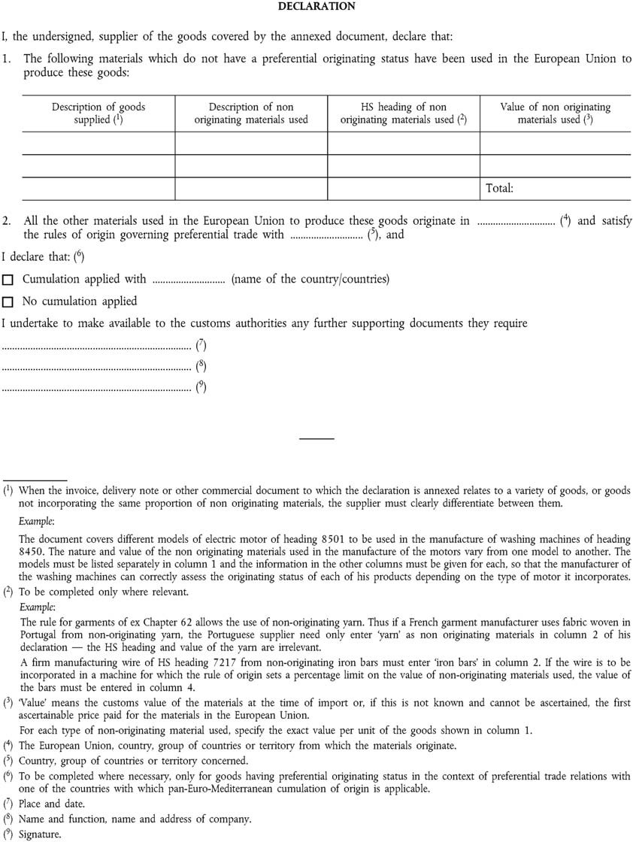

1. When the invoice, delivery note or other commercial document to which declaration is annexed relates to a variety of goods,or goods not incorporating the same proportion of non originating material, the supplier must clearly differentiate between them.
2. To be completed only where relevant.
3. Value means the customs value of the materials at the time of import or if this is not known and cannot be ascertained, the first ascertainable price paid fort he materials in Turkey.
4. Turkey, The Union, Switzerland, Norway, country or group of countries.
5. Country or group of countries
6. To be completed where necessary, only for the goods having preferential originating status in the contex of preferential trade relations with one of the countries with which Pan-Euro-Med cumulation of origin is applicable.
7. Date and place
8. Name and fuction, name and addres of the company.
9. Signature